Step-1: List the images.

**Command: # docker images**

**or**

**Command: # docker image ls**

**Status:**

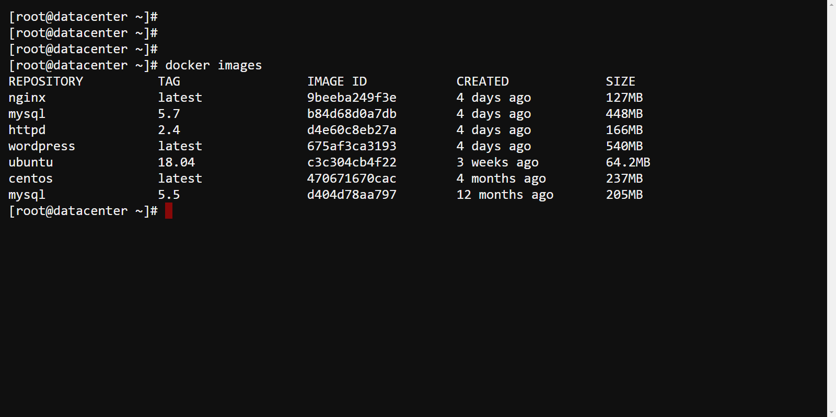

Step-2: Now, Start the two ubuntu containers:

**Command: # docker container run -itd ubuntu bash**

**Command: # docker container run -itd ubuntu bash**

**And perform each task in the containers.**

**After that attach the container: do as same on another container.**

**Command: # docker container attach container_id**

**Status:**

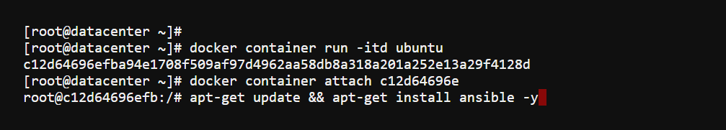

Step-2: Now, Commit the container and create new container image.

**Command: # docker container commit container_id1 client**

**Command: # docker container commit container_id2 server**

**Status:**

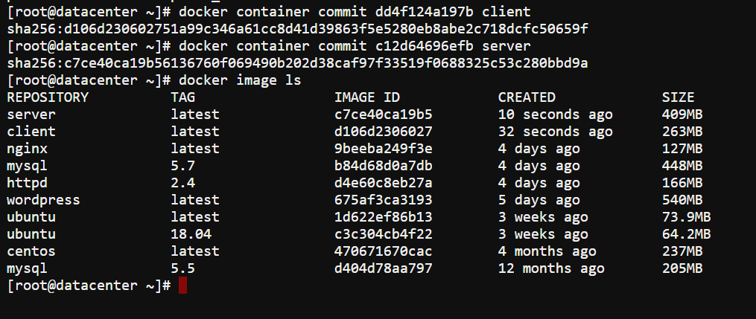

Step 3. Before push the container you have to sign-in with hub.docker.com.

**Command: # docker login**

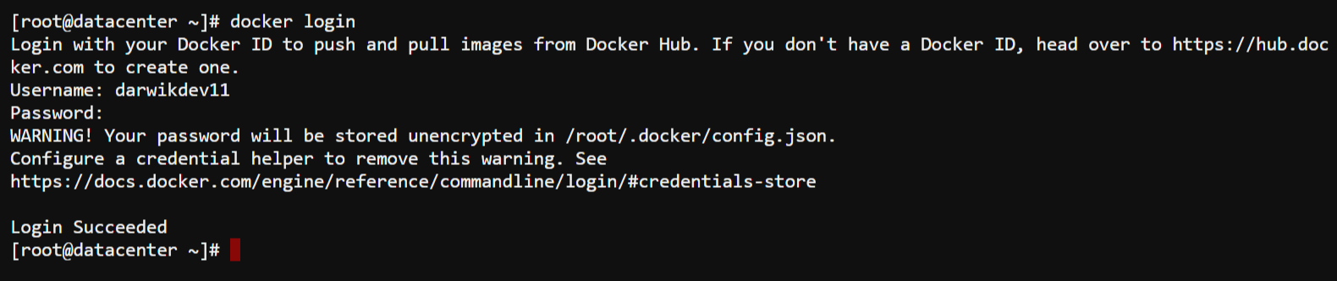

Step-4: Now, again commit the container.

**Command: # docker container commit c12d6496efb darwikdev11/ansi_server**

**# docker container commit dd4f124a197b darwikdev11/ansi_client**

Step-5: Now, Define the tag. And push the image to docker hub.

**Command: # docker image tag darwikdev11/ansi_server darwikdev11/ansi_server**

**# docker image ls**

**# docker push darwikdev11/ansi_server**

**Status:**

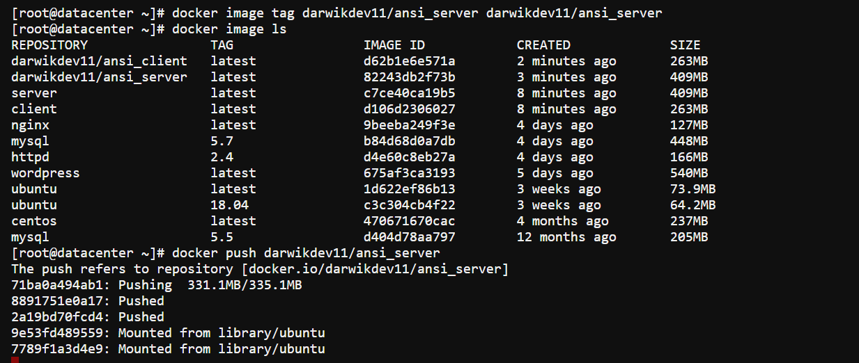

Step-6: Now, pushing client machine.

**Command: # docker push darwikdev11/ansi_client**

**Status:**

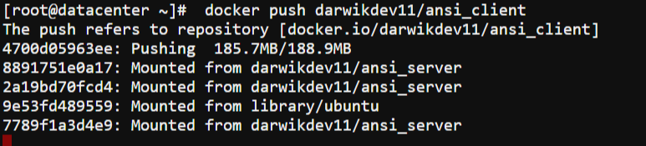

Search the image in private registry.

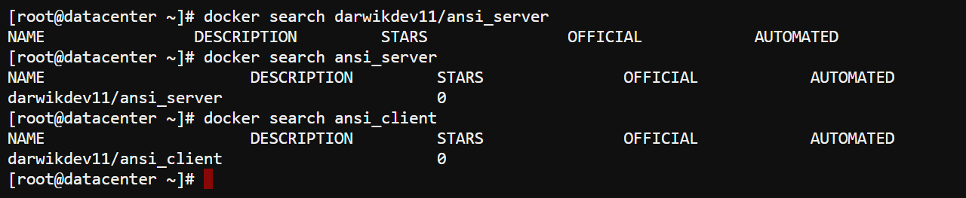

Step.6: After the pushed image,

Login: <https://hub.docker.com>

you can check your images in repository.

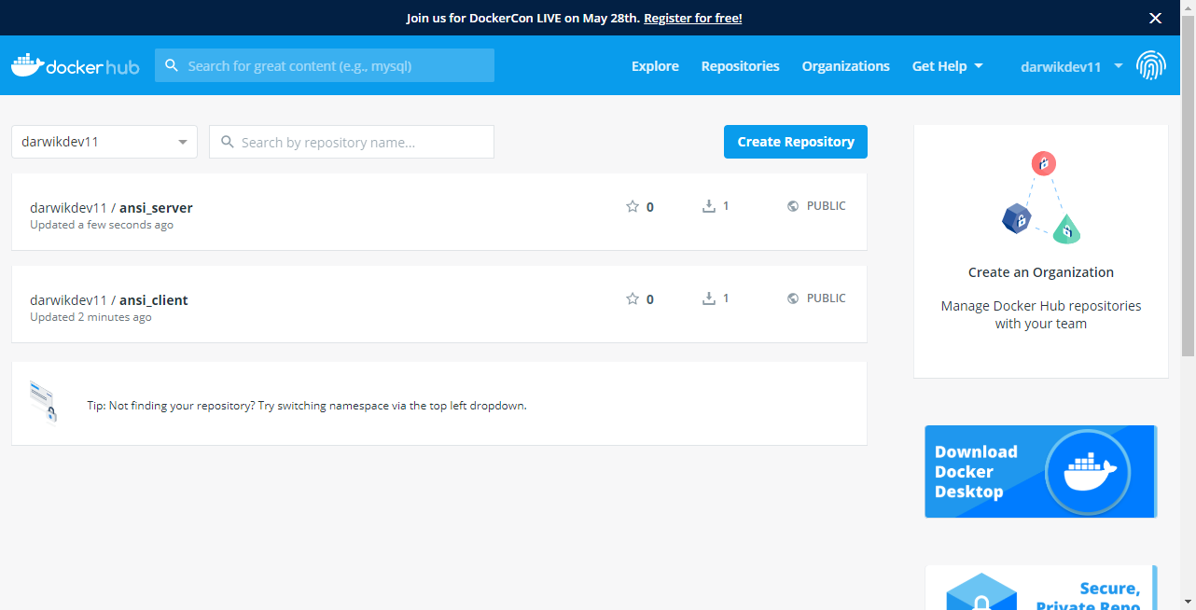

**NOTE: Follow these instructions if you don’t have an account.**

Step-3.0: If you don’t have any account, Now, signup today.

Now, go to website : <http://hub.docker.com>



Step-3.1: If you an account, Now, sign-in.

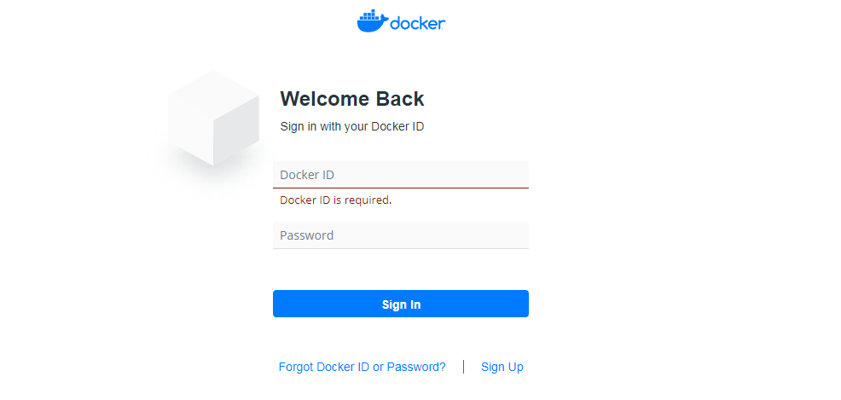

Step-3.2: After sign-in, you can check your repositories in your account.

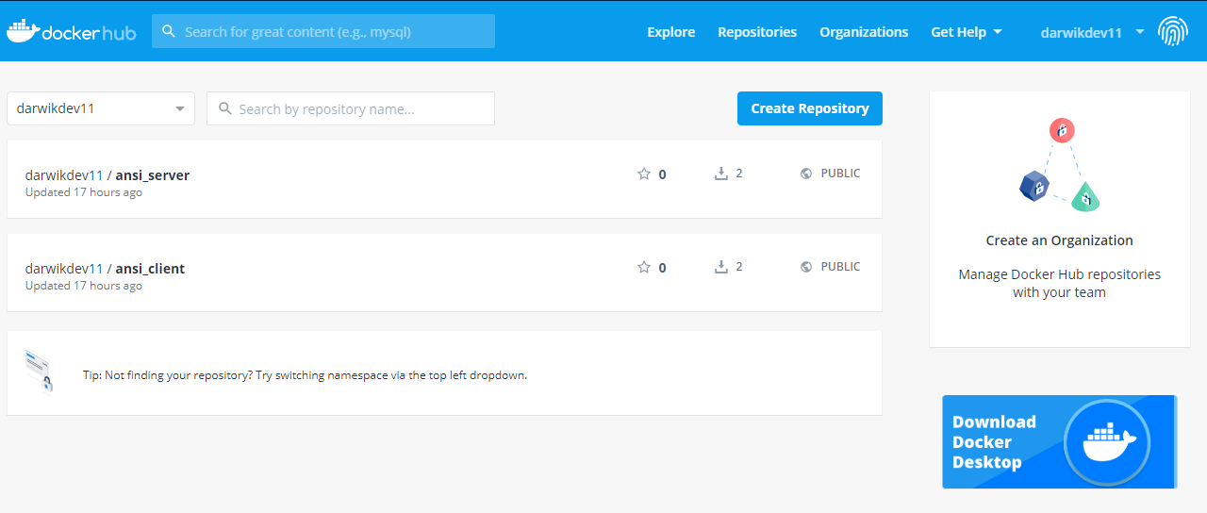

Step-3.3: Create your own repository.

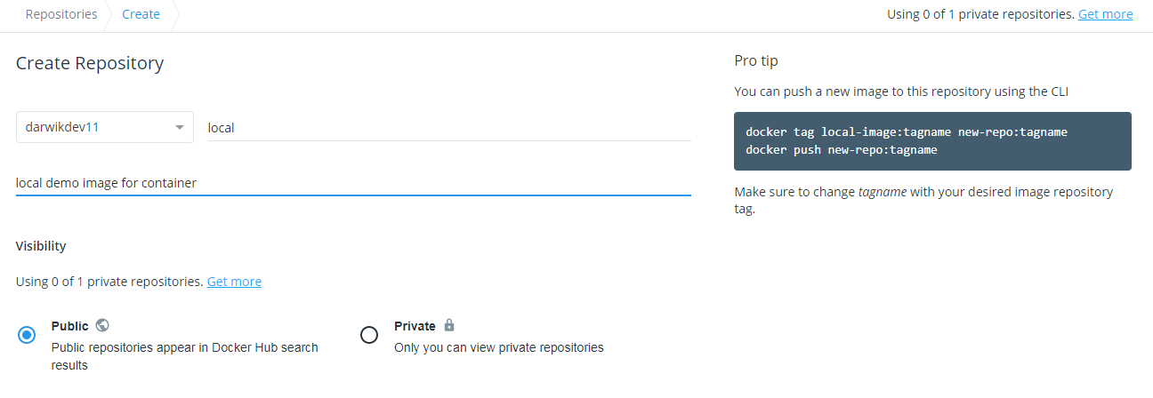

Step-3.4: tap to create a repository.

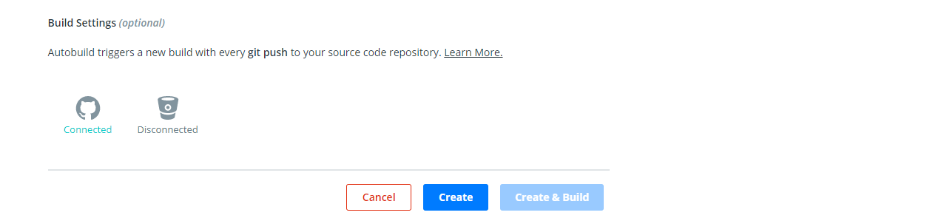

Step-3.5: after the created repository, look like this :

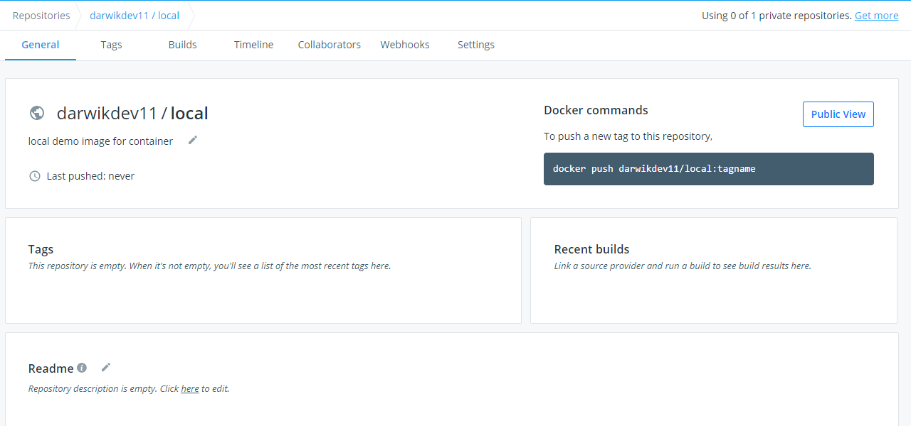

Step-3.6: For remove : go to settings, and delete the repository.

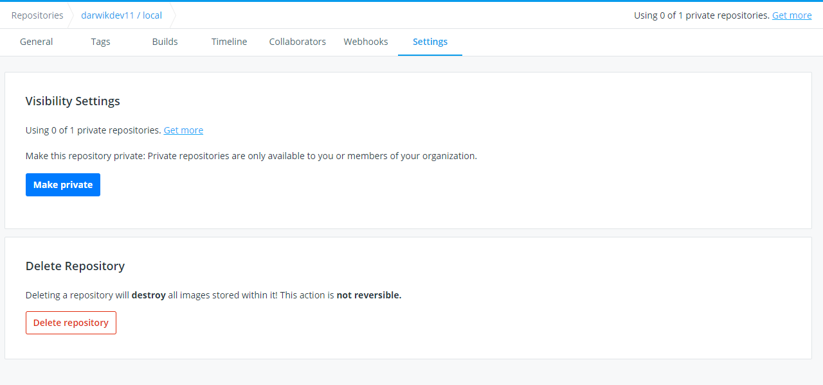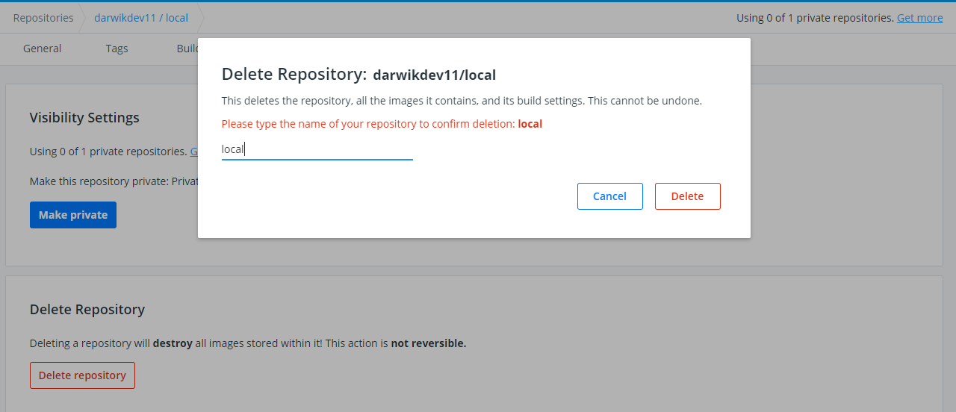

Step-4: Search a new image.

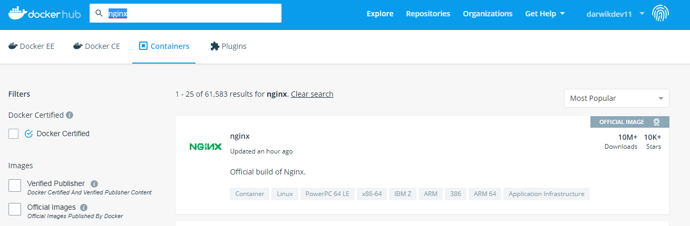

Step-4.1: now you can pull the image.

**Command: # docker pull nginx**

